EDA Report on Average
Performance Bonus

Deanna Graves
7/9/26

An rudimentary analysis of correlation between multiple
factors and performance bonus by employee.

Table of Contents

- Title Page
- Table of Contents
- Project Overview and Attribute Information
- Dataset Statistics and Histograms
- Scatter Plots
- Relationship and correlation charts
- Additional Visuals
- Summary
- References

Project Overview and Attribute Information

  - Purpose - The purpose of this EDA is to analyze the contributing or correlating factors associated with the annual team member bonus.

  - Associated Factors - The associated factors explored include total sales, years with the company, and number of accounts. This analysis focuses on the average annual bonus from the three previous fiscal years.

  - Expectation - The expectation is that each factor - years with the company, number of accounts and total sales - will all have a positive correlation with the dollar amount of the annual bonus for each salesperson respectively.

  - Process - The process will include cleaning the dataset of any duplicate data or irrelevant outliers, performing base - line calculations, and generating graphics to reflect the results.

Dataset Statistics and Histograms

Bonus
  - Mean – 11,129.43
  - Median – 12,499.3425
  - Mode – N/A
  - Range – 27,741.4998
  - Variance – 84,230,048.43
  - Standard Deviation – 9177.69298

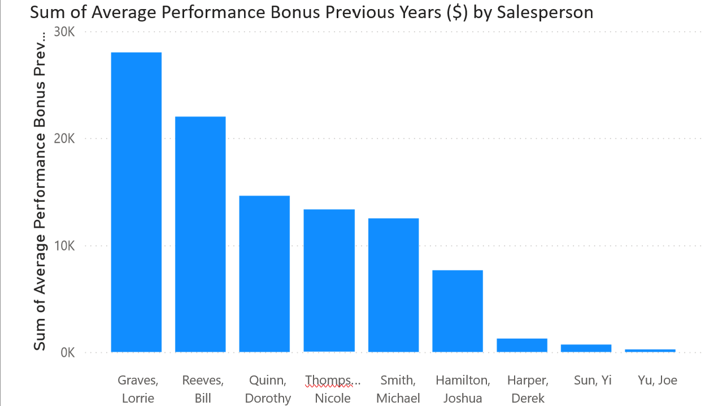

Years with Company
  - Mean – 8.22
  - Median - 7
  - Mode - 3
  - Range - 20
  - Variance – 37.5
  - Standard Deviation – 6.12

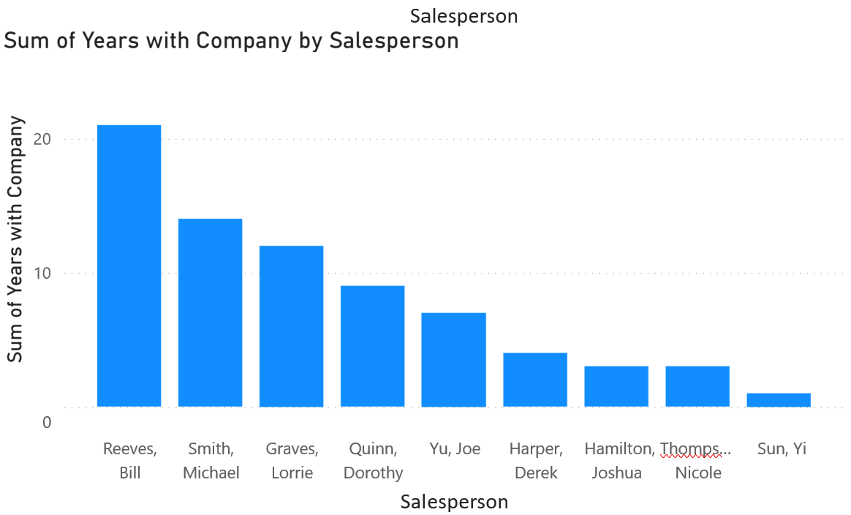

Total Sales
  - Mean – $193,243.16
  - Median – $87,654.21
  - Mode – N/A
  - Range – $438,680.98
  - Variance – 22,864,155,528
  - Standard Deviation – 151,208.9797
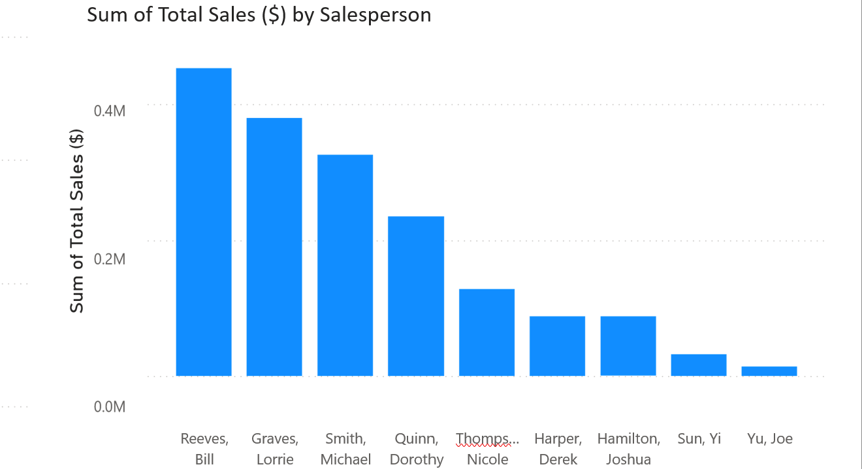

Number of Accounts

  - Mean – 61.11
  - Median - 28
  - Mode – N/A
  - Range - 169
  - Variance – 3442.098
  - Standard Deviation – 58.668
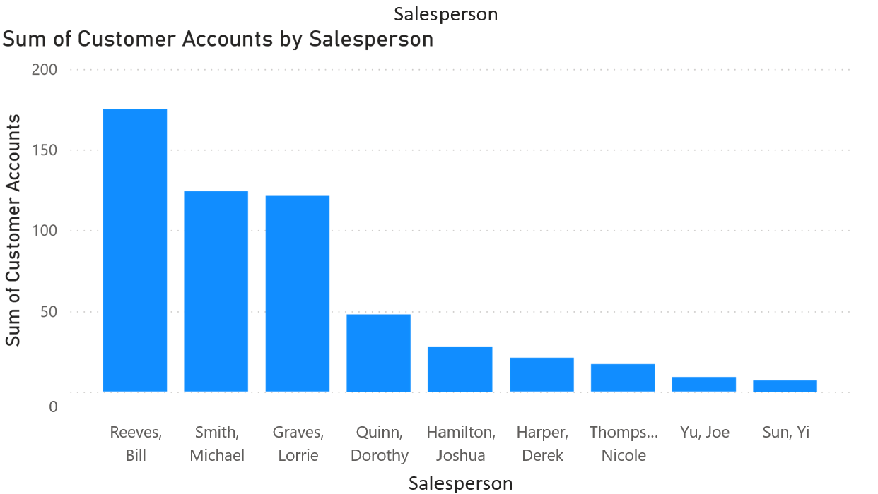

Scatter Charts Showing Relationships Between All Variables

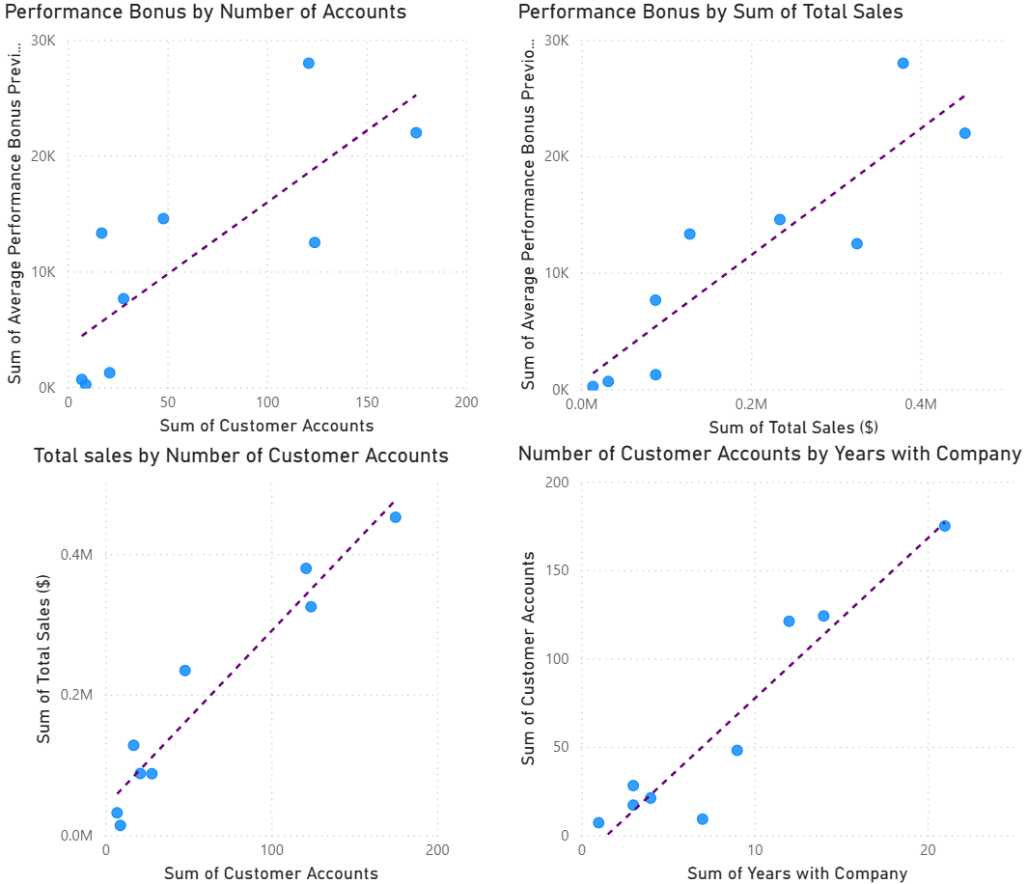
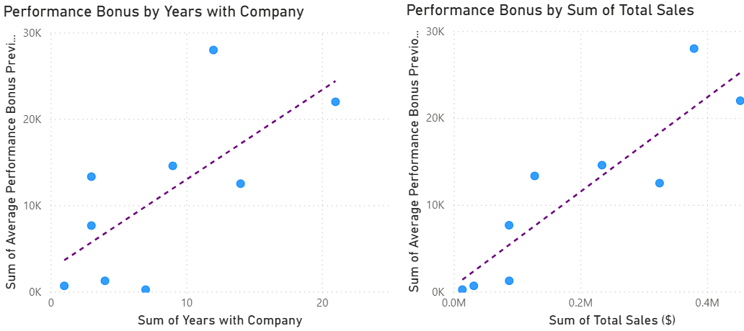

Relationships and Correlations Exemplified by Scatter Charts

Performance Bonus by Number of Accounts:
- Somewhat positive correlation between bonus amount and number of accounts; high level of variance

Performance Bonus by Sum of Total Sales:
- Strong positive correlation between bonus amount and total sales

Total Sales by Number of Customer Accounts:
- Number of accounts has a nearly linear positive correlation with bonus amount

Number of Customer Accounts by Years with Company
- Number of accounts has a positive correlation with years with company excluding a few outliers

Performance Bonus by Years with Company
- Performance bonus has low to no correlation with years spent in company

Performance Bonus by Sum of Total Sales
- Total sales have a positive correlation with bonus amount

Additional Visuals

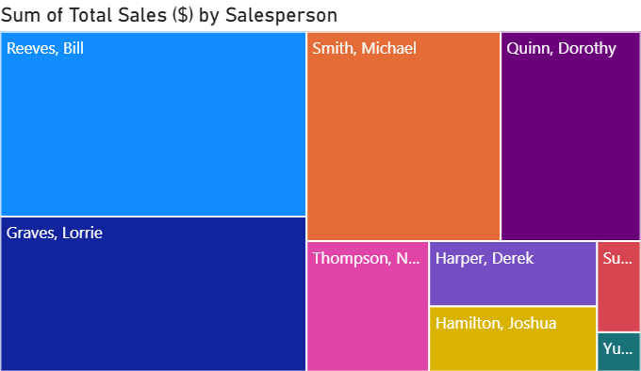
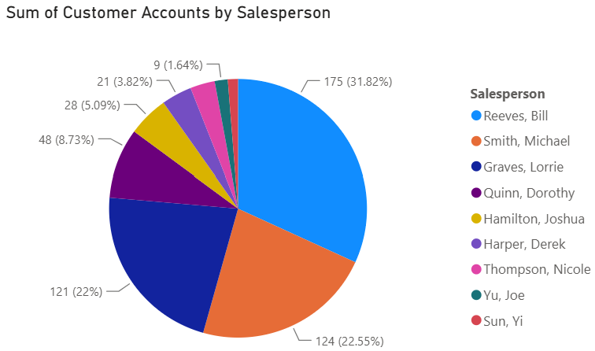

Summary

This analysis has addressed the correlation between annual bonus as related to years with the company, total number of accounts and total sales.

- The bar charts show each factor individually.

- The scatter charts show the correlations between these factors.

- The relationships are noted and discussed.

- Two additional diagrams are added for further analysis of the contributing factors.

References

Excel Data Sheet – Sales Bonus Data

https://ivylearn.ivytech.edu/courses/1404116/files/140724588?verifier=3sKnfbaCVsMzJKn61E26GqP7R6t1bcmyFrckJJ6F&wrap=1

